Extension until 31-03-2020 granted by the Breast Service Speciality Governance Group on 10-09-2019, pending completion of review and publication of national guidance.
Clinical Guideline for:
Management of Breast Cancer Treatment-induced Bone Loss
SUMMARY
This guideline outlines the surveillance and treatment of bone density following adjuvant treatment for breast cancer.

KEY POINTS
Risk factors:

- Older age
- Female
- Steroid use
- 2 ° osteoporosis
- Lower BMI
- Smoking
- Excess alcohol
- Low BMD

Adjuvant Breast Cancer Treatment associated with bone loss

- Aromatase Inhibitors (AI):
- Postmenopausal: 1–3% /year
- Young Women: Ovarian Suppression (OS)/ Aromatase Inhibitors (AI):
7-8% per year

- Pre-treatment with Tamoxifen (at 2-5 years) may reduce the adverse bone effects
- However, skeletal status should still be assessed at commencement of AI

Tamoxifen
- In premenopausal women with high-circulating oestrogen, Tamoxifen causes bone loss for 1-2 years. This is not persistent through 5 years of Tamoxifen therapy

- In post-menopausal women with low-circulating oestrogen, Tamoxifen causes a small but significant increase in BMD.

  - Post-menopausal > 45 on Tamoxifen, (no monitoring required)
  - Post-menopausal > 45 on no endocrine treatment (no monitoring required)

CONTENTS

1. INTRODUCTION 2
2. DEFINITIONS 2
3. ALGORITHMS 2
3.1 Algorithm 1: Premature menopause, or Ovarian Suppression (OS) AI 3
3.1 Algorithm 1: Premature menopause, or Ovarian Suppression (OS) AI 4
3.1 Algorithm 2: Post-menopausal AI 5
4. PRESCRIBING OF AI .7
4.1 Prescribing Treatments for Patients 7
5. MONITORING COMPLIANCE WITH THIS GUIDELINE 7
6. ASSOCIATED CLINICAL GUIDELINES OR POLICIES/ PROCEDURES 7
7. PUBLICATION DETAILS 8
APPENDIX 1: BONE DENSITOMETRY (DXA) REFERRAL FORM 9
APPENDIX 2: UK EXPERT GROUP (2008). GUIDANCE FOR THE MANAGEMENT FOR BREAST CANCER TREATMENT-INDUCED BONE LOSS (pages 2-3; 17–21)…………………………………….……………………………………10

1. INTRODUCTION

1.1 This guideline is based on the Consensus Statement UK Expert Group July 2008, replacing “Bone Protection for Cancer Patients on AI 45-75”.

2. DEFINITIONS

2.1 Osteoporosis is defined as a skeletal disorder characterised by compromised bone strength; predisposing to an increased risk of fracture.

3. ALGORITHMS
See pages 3-6

3.1 Algorithm 1: Premature menopause, or Ovarian Suppression (OS) AI

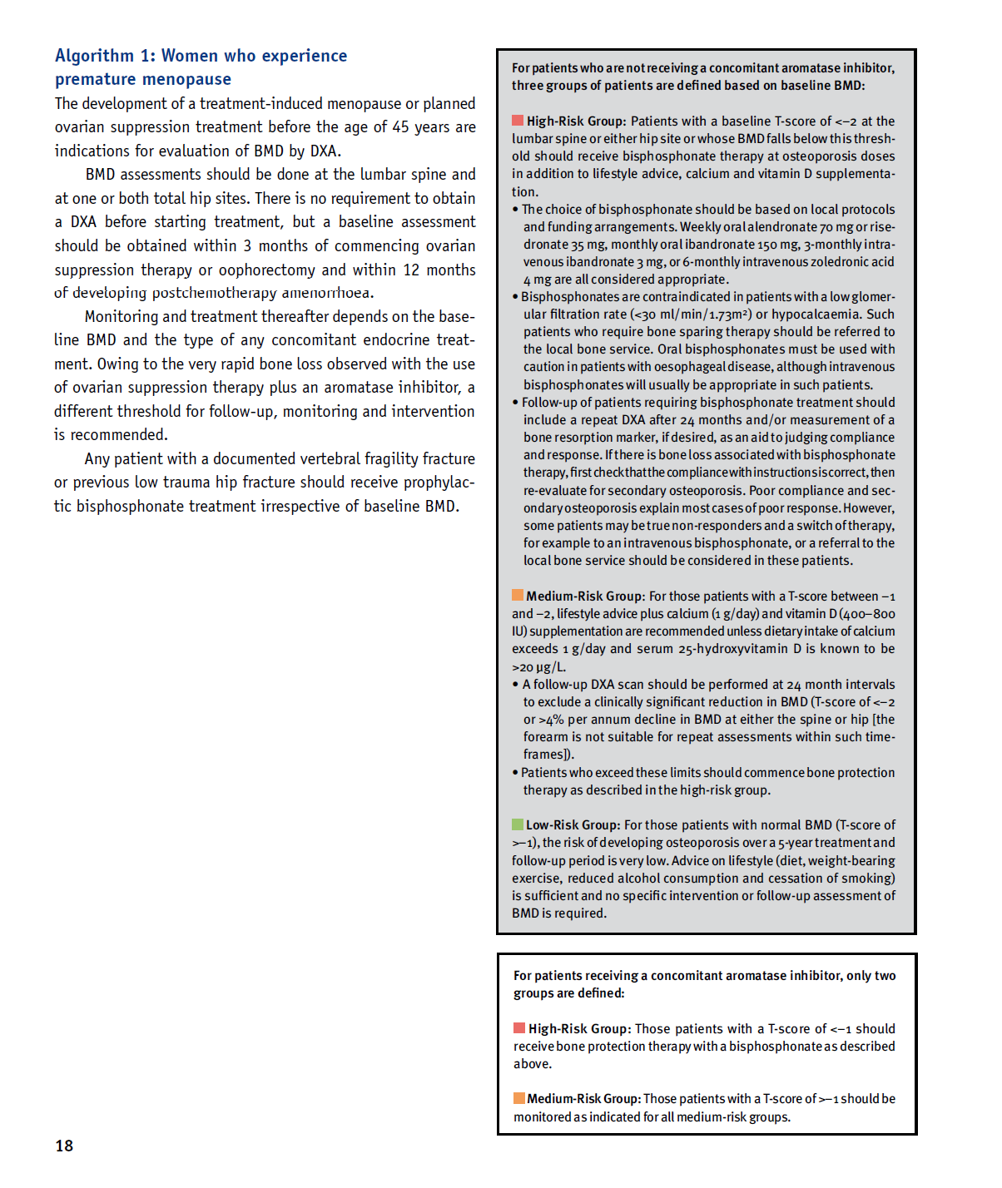

3.1 Algorithm 1: Premature menopause, or Ovarian Suppression (OS) AI
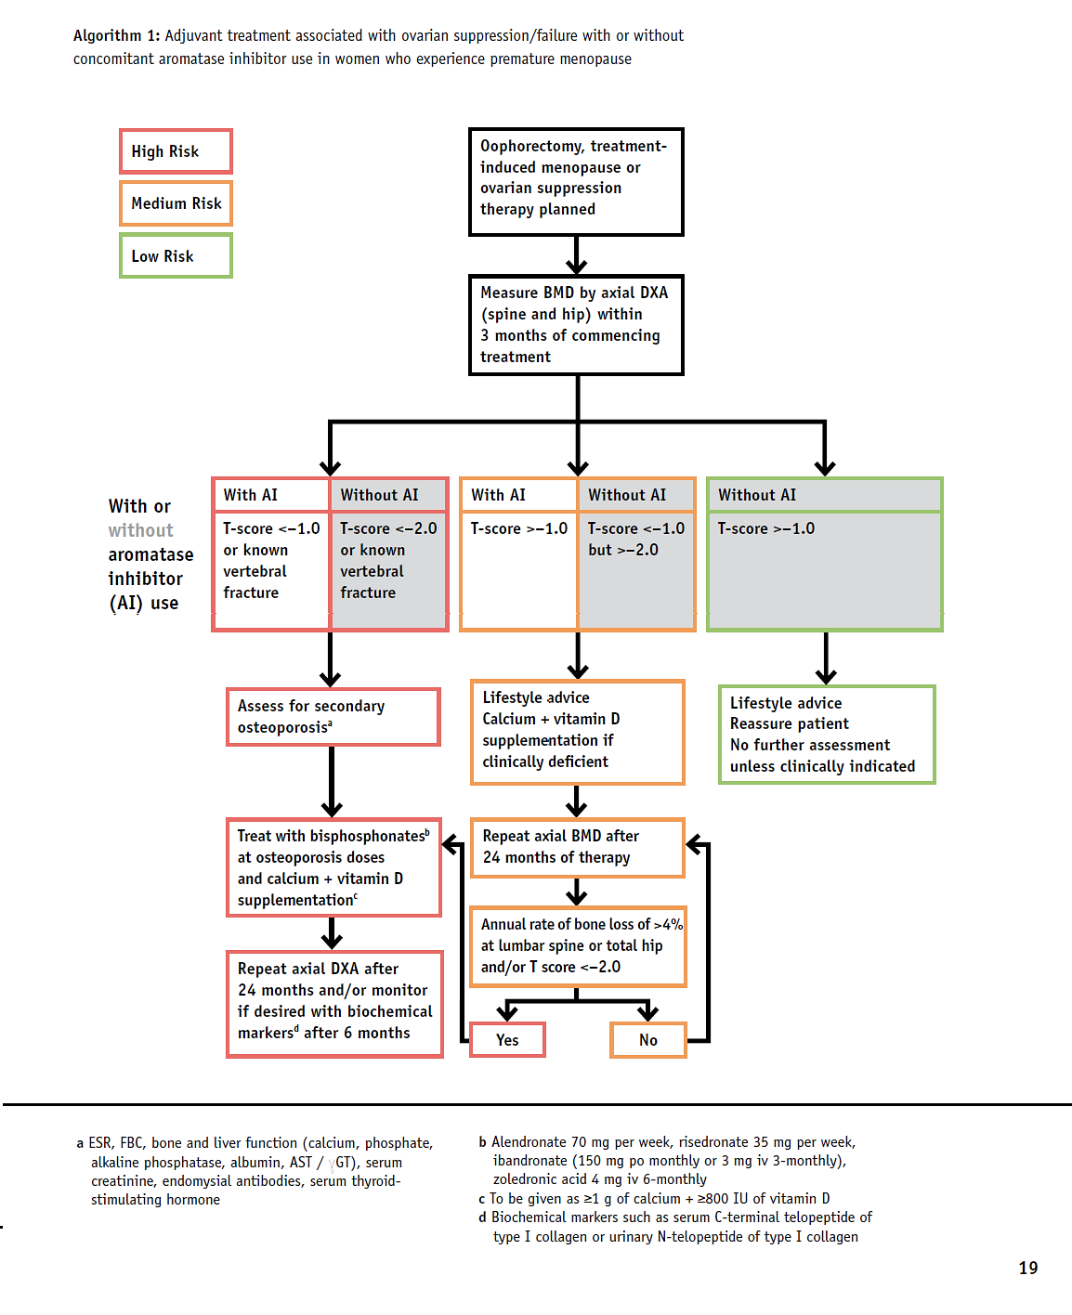

UK Expert Group (2008). Guidance for the Management of Breast Cancer Treatment-Induced Bone Loss (pages 18–21)

3.1 Algorithm 2: Post-menopausal AI
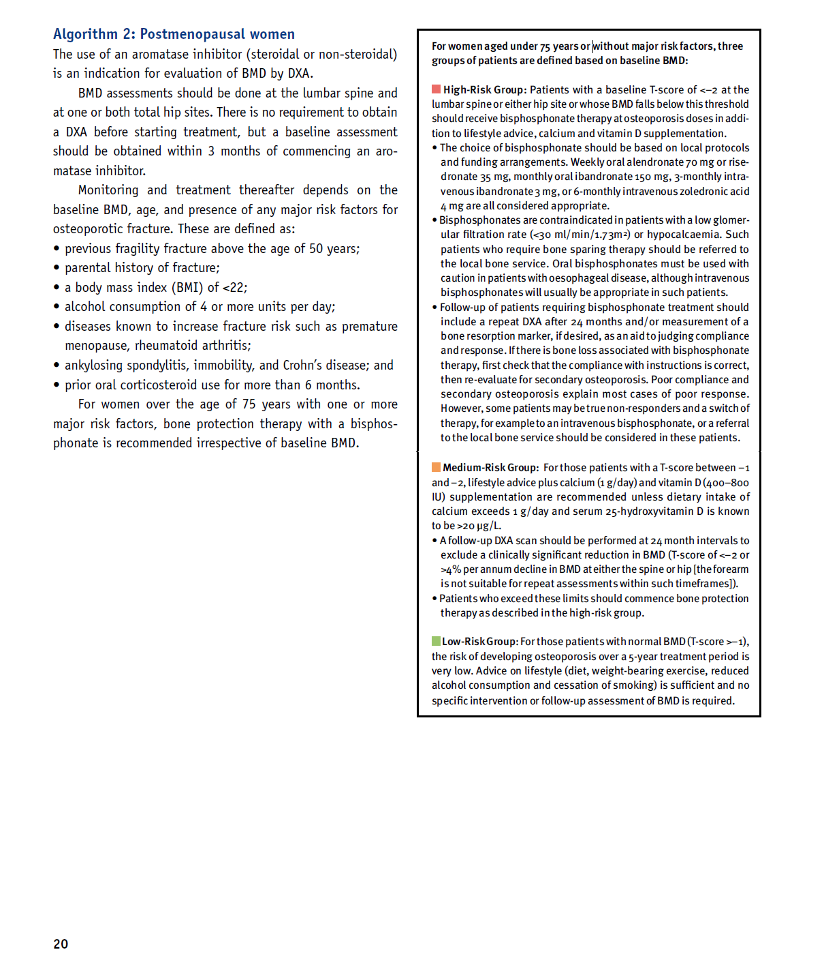

UK Expert Group (2008). Guidance for the Management of Breast Cancer Treatment-Induced Bone Loss (pages 18–21)

3.2 Algorithm 2: Post-menopausal AI

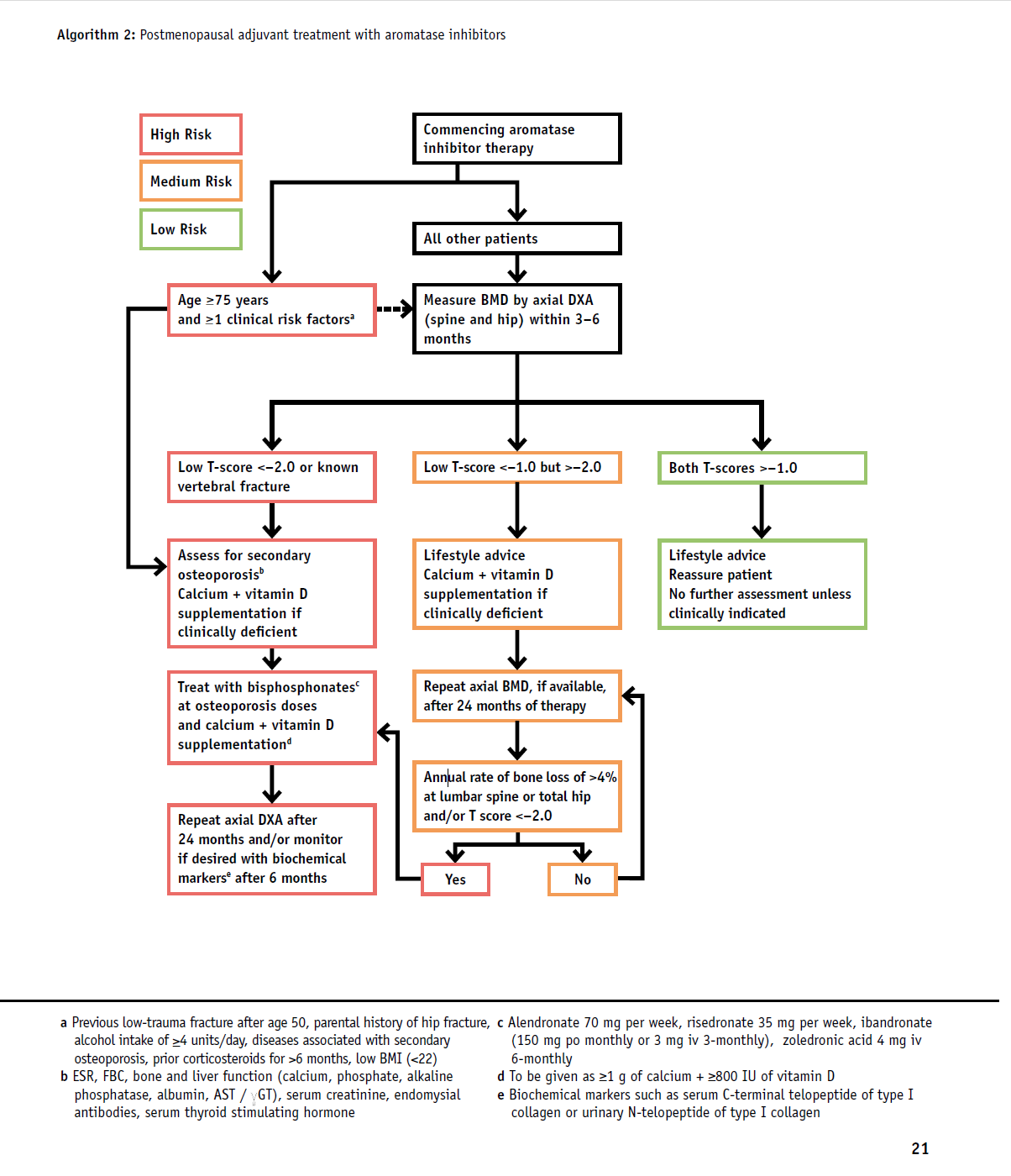

UK Expert Group (2008). Guidance for the Management of Breast Cancer Treatment-Induced Bone Loss (pages 18–21)

4. PRESCRIBING OF AI

4.1 Prescribing Treatments for Patients

- For those undergoing ovarian suppression +/ - an AI, the clinician organising the treatment should order the baseline DEXA scan and the 2 year follow-up scan

- For those being treated with AI, the clinician who initiates the AI should organise the baseline DEXA and 2 year follow-up scan
- For those on a “switch regime”, the clinician who initiates the AI should organise the DEXA scan and another at the end of the AI treatment

- The patient needs to be made aware of the possible effect of treatment with an AI, and be given written information -- see Osteoporosis and Breast Cancer Treatment factsheet (Breast Cancer Care, 2015)

- Results of DEXA will go to the clinician who organised the DEXA scan

- The clinician should inform the patient’s GP of the result by means of a copy of the report, and suggested treatment (see algorithm)

- No indication for DEXA scan at the end of treatment regime (guidelines)

- Following 2 year Dexa or al end of AI, GP to be informed patient will need follow up Dexa scan at the end of treatment (usually 5 years)

5. MONITORING COMPLIANCE WITH THIS GUIDELINE

5.1 Once circulated to Surgical and Oncology teams, an audit of the current practice should be undertaken every 2 years.

6. ASSOCIATED CLINICAL GUIDELINES OR POLICIES/ PROCEDURES

UK Expert Group (2008). Guidance for the Management of Breast Cancer Treatment-Induced Bone Loss: A consensus position statement from UK Expert Group. July 2008; update September 2015. London: UK Expert Group.
Available at: https://www.nos.org.uk/NetCommunity/Document.Doc?id=124
[Accessed 14-14-15]

Breast Cancer Care (2015). Osteoporosis and Breast Cancer Treatment factsheet. London: Breast Cancer Care. Available at: https://www.breastcancercare.org.uk/sites/default/files/publications/pdf/osteoporosis-breast-cancer-treatment_20.pdf [Accessed 14-14-15]

7. PUBLICATION DETAILS

Author of Clinical Guideline | Diane Cameron, Trust Breast Physician
Division/ Department responsible for Clinical Guideline | Surgical Services Division / Breast Service
Contact details | x2397, dianecameron@nhs.net
Version number | v1.0
Replaces version number | n/a
Date written | 23/11/15
Approving body and date approved | Breast Service Governance Group  07/03/16
Review date (3-6 months prior to expiry date) | 12/10/18
Expiry date | 07/03/19
Date document becomes live | 18/04/16

APPENDIX 1: BONE DENSITOMETRY (DXA) REFERRAL FORM

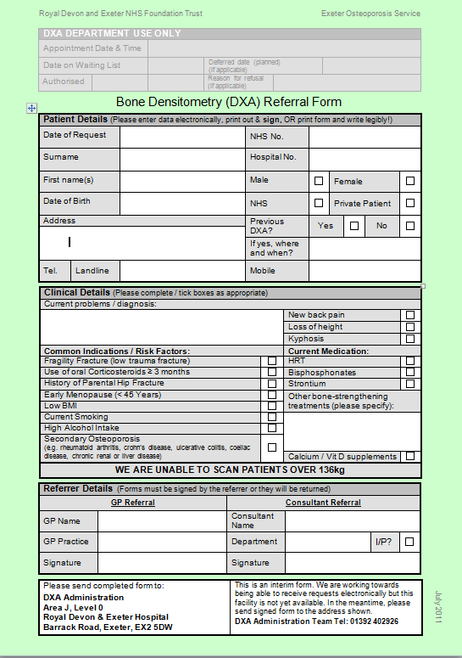

APPENDIX 2: UK EXPERT GROUP (2008). GUIDANCE FOR THE MANAGEMENT FOR BREAST CANCER TREATMENT-INDUCED BONE LOSS (pages 2-3; 17–21)

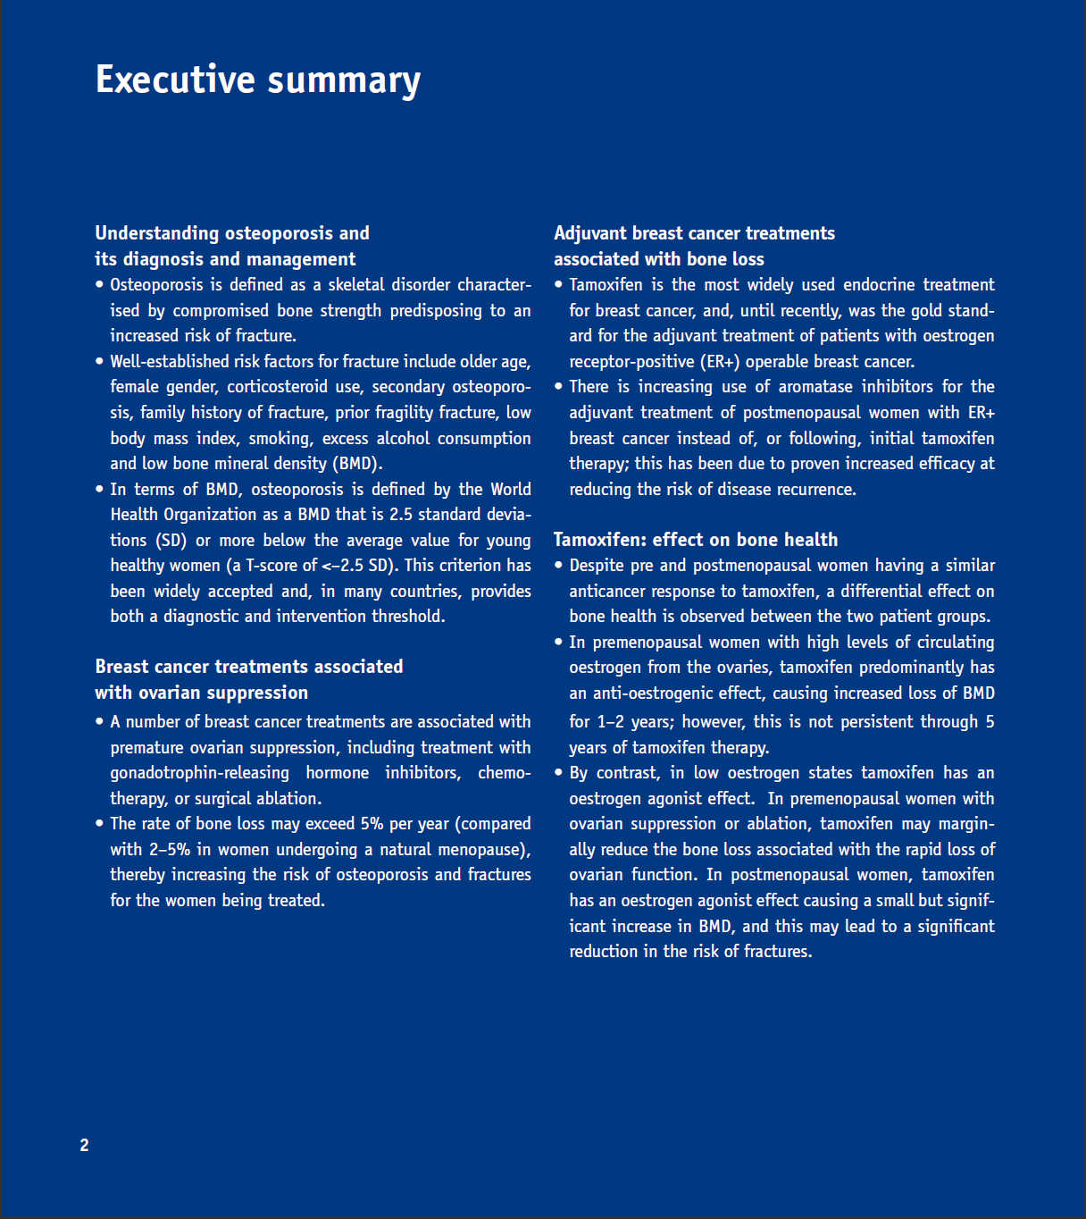
UK Expert Group (2008). Guidance for the Management of Breast Cancer Treatment-Induced Bone Loss (pages 2–3)

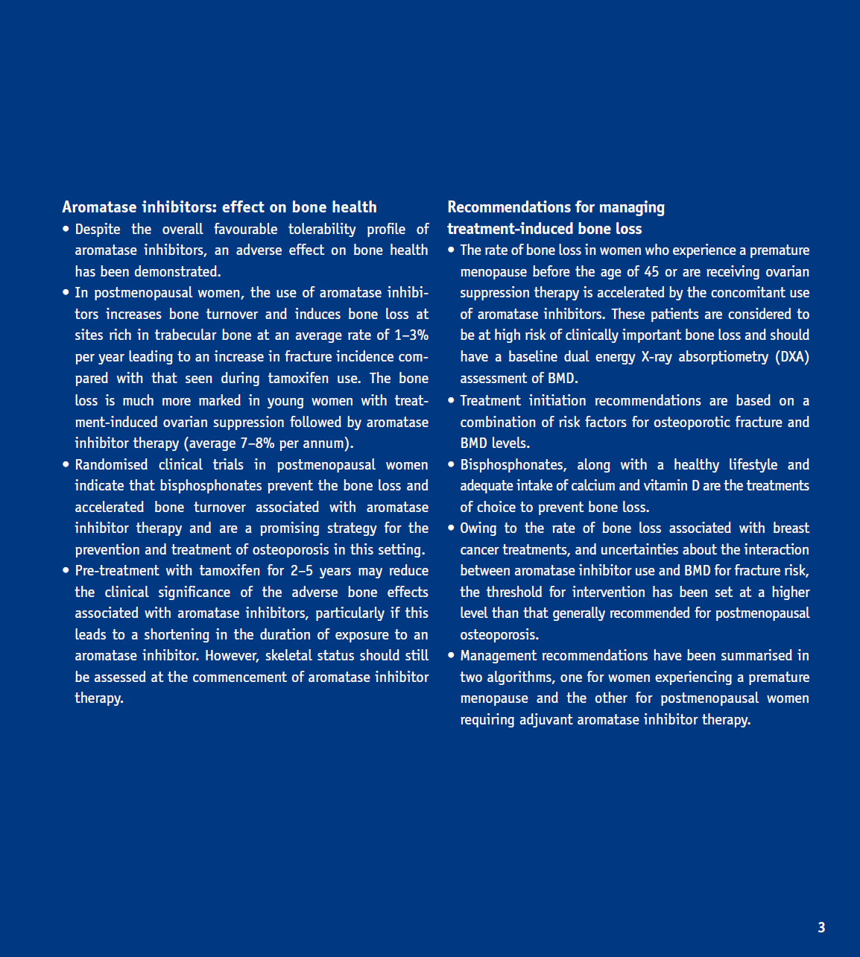
UK Expert Group (2008). Guidance for the Management of Breast Cancer Treatment-Induced Bone Loss (pages 2-3)
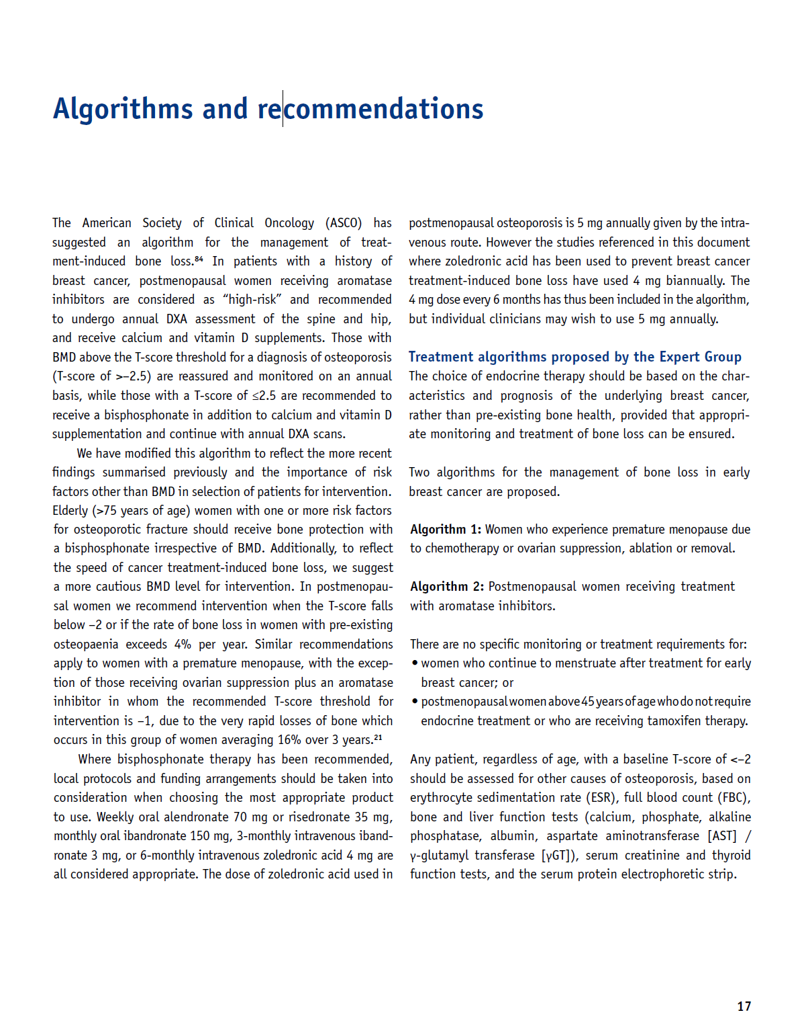
UK Expert Group (2008). Guidance for the Management of Breast Cancer Treatment-Induced Bone Loss
(pages 17–21)

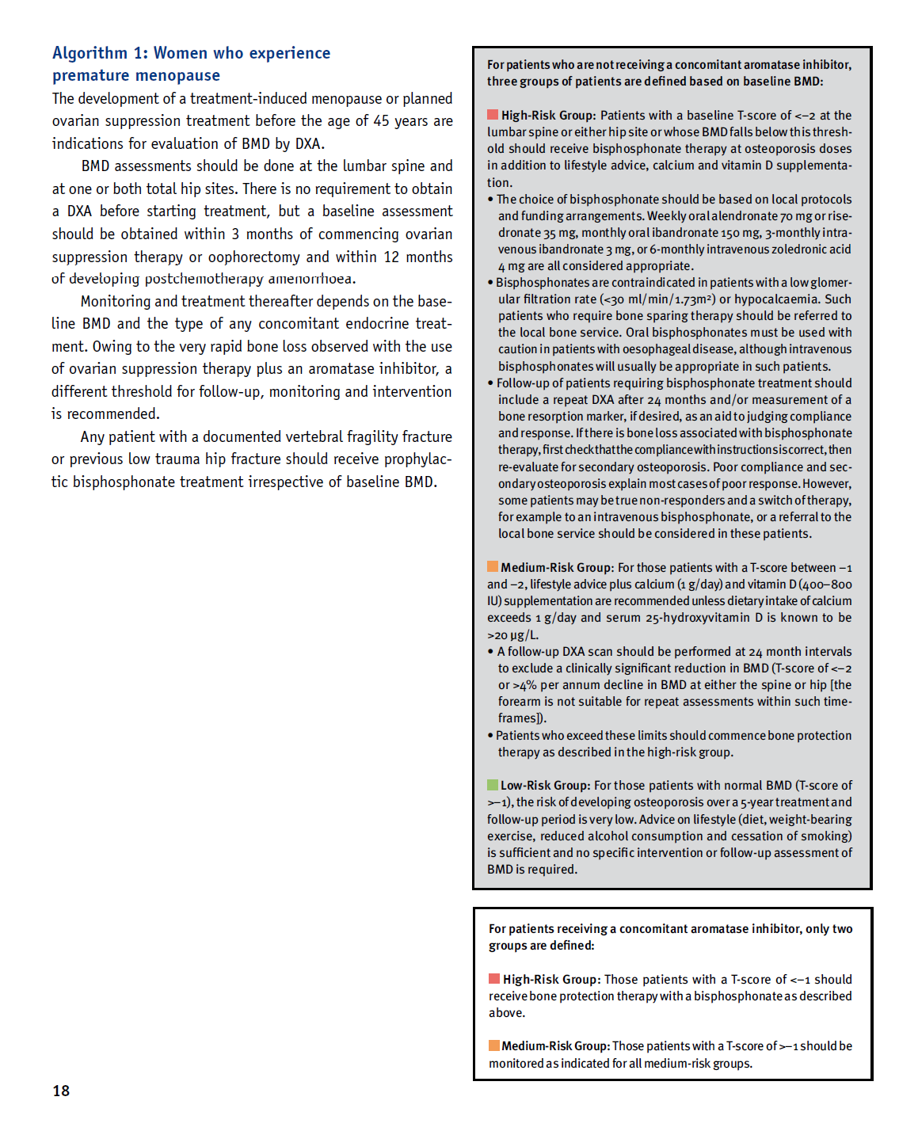

UK Expert Group (2008). Guidance for the Management of Breast Cancer Treatment-Induced Bone Loss
(pages 17–21)
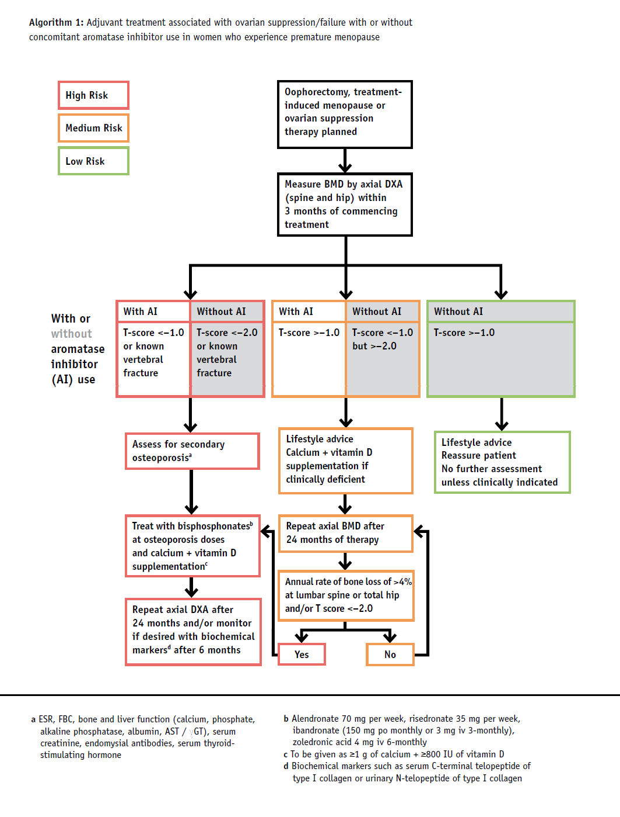

UK Expert Group (2008). Guidance for the Management of Breast Cancer Treatment-Induced Bone Loss
(pages 17–21)


UK Expert Group (2008). Guidance for the Management of Breast Cancer Treatment-Induced Bone Loss
(pages 17–21)
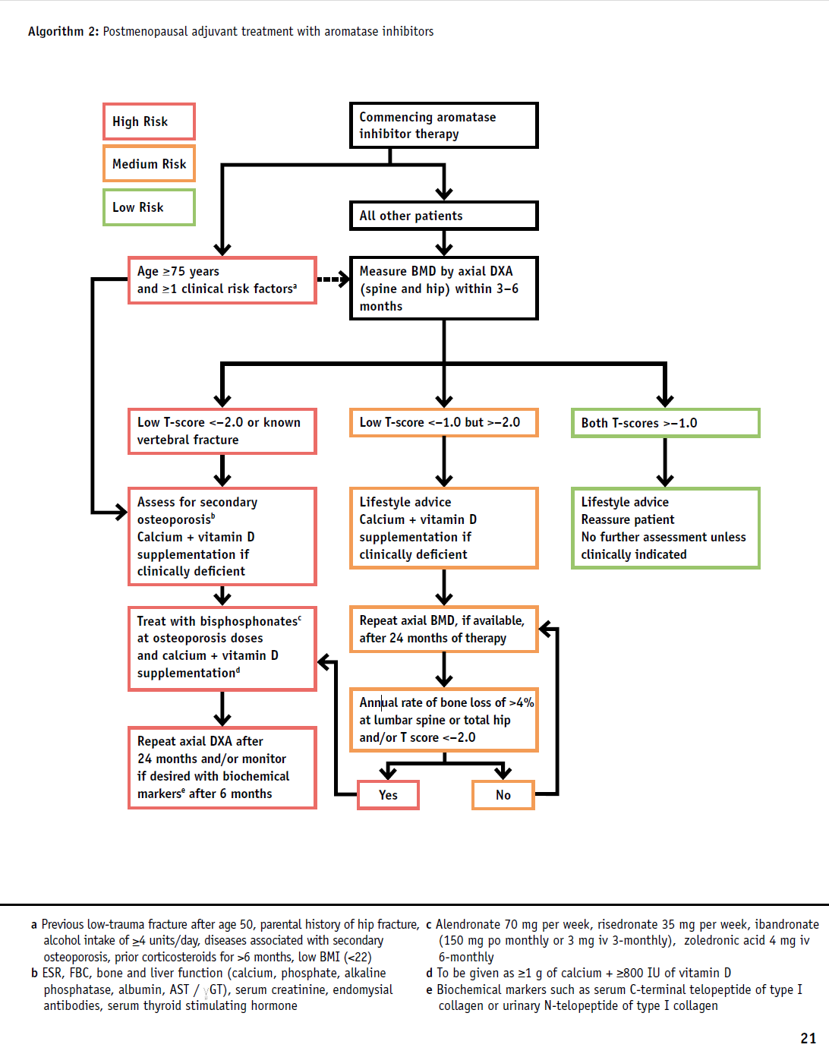

UK Expert Group (2008). Guidance for the Management of Breast Cancer Treatment-Induced Bone Loss
(pages 17–21)

